Exploratory Data Analysis

When the data was downloaded from LendingClub.com the following 3 rounds of data analysis were completed to gain an understanding of the data.

Exploratory Data Analysis 1
First round of Data exploration 1
Second look at the data 17
Third Look at the data Exploration and discovery of the predictive strength of each features: 25

First round of Data exploration

Data Summary
summary(LA)
loanamnt termmonths intrate installment grade
Min. : 500 Min. :36.00 Min. :0.0542 Min. : 15.67 Length:253235
1st Qu.: 7475 1st Qu.:36.00 1st Qu.:0.1099 1st Qu.: 241.97 Class :character
Median :12000 Median :36.00 Median :0.1367 Median : 366.82 Mode :character
Mean :13565 Mean :41.29 Mean :0.1387 Mean : 419.37
3rd Qu.:18225 3rd Qu.:36.00 3rd Qu.:0.1659 3rd Qu.: 547.95
Max. :35000 Max. :60.00 Max. :0.2606 Max. :1408.13

subgrade emplength homeownership annualinc verificationstatus
Length:253235 10+ years:75937 : 0 Min. : 1896 : 0
Class :character 2 years :23612 ANY : 1 1st Qu.: 45000 Not Verified :87485
Mode :character < 1 year :21045 MORTGAGE:124548 Median : 62000 Source Verified:71545
3 years :20566 NONE : 44 Mean : 72056 Verified :94205
5 years :18237 OTHER : 177 3rd Qu.: 86000
1 year :16947 OWN : 21334 Max. :7141778
(Other) :76891 RENT :107131
issued purpose region dti
Length:253235 debt_consolidation:147817 Length:253235 Min. :0.0000
Class :character credit_card : 51028 Class :character 1st Qu.:0.1078
Mode :character home_improvement : 14616 Mode :character Median :0.1622
other : 14290 Mean :0.1652
major_purchase : 6245 3rd Qu.:0.2197
small_business : 4977 Max. :0.3999
(Other) : 14262
inqlast6mths mthssincelastrecord openacc pubrec revolbal
Min. : 0.0000 0-77 : 14823 Min. : 1.0 Min. : 0.0000 Min. : 0
1st Qu.: 0.0000 78-129: 16159 1st Qu.: 7.0 1st Qu.: 0.0000 1st Qu.: 5972
Median : 1.0000 Never :222253 Median :10.0 Median : 0.0000 Median : 11061
Mean : 0.8996 Mean :10.9 Mean : 0.1371 Mean : 15320
3rd Qu.: 1.0000 3rd Qu.:13.0 3rd Qu.: 0.0000 3rd Qu.: 19187
Max. :33.0000 Max. :76.0 Max. :11.0000 Max. :1746716

revolutil initialliststatus outprncp outprncpinv mthssincelastmajorderog
Min. :0.0000 : 0 Min. : 0 Min. : 0.0 >75 : 2863
1st Qu.:0.3750 f:186358 1st Qu.: 0 1st Qu.: 0.0 0-45 : 25381
Median :0.5690 w: 66877 Median : 0 Median : 0.0 46-75: 17797
Mean :0.5519 Mean : 391 Mean : 390.8 Never:207194
3rd Qu.:0.7460 3rd Qu.: 0 3rd Qu.: 0.0
Max. :8.9230 Max. :31554 Max. :31531.4

applicationtype desclength emptitlelength titlelength numofdelinq
: 0 Min. : 0.00 Min. : 0.00 Min. : 0.00 Min. : 0.0000
INDIVIDUAL:253235 1st Qu.: 0.00 1st Qu.:10.00 1st Qu.:13.00 1st Qu.: 0.0000
Median : 0.00 Median :16.00 Median :18.00 Median : 0.0000
Mean : 84.38 Mean :16.27 Mean :16.97 Mean : 0.5211
3rd Qu.: 86.00 3rd Qu.:22.00 3rd Qu.:19.00 3rd Qu.: 1.0000
Max. :3966.00 Max. :78.00 Max. :81.00 Max. :29.0000

statusClass
Default : 52128
No_Default:201107

Check distributions

Loan Term

table(LC$termmonths)
36 60
197331 55813

Annual income
============
There’s a very odd data point in annual income of > $7m. We’re going to assume this to be an outlier since it’s very unlikely for somebody with this income to ask for a small loan.

densityplot(LC$annualinc)

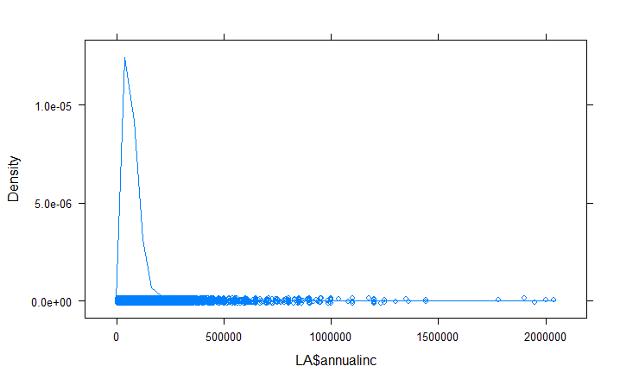

Doing a density plot of annual income it looks like majority of the cases ar for annual incomes under $500,000 however I will set a benchmark of $1m
This removed 34 cases/outliers
LC <- filter(LC, annualinc <= 1000000)

Revolving Balance
==============

As with annual income, there is a max value for revolbal of circa $1.7m so a density plot shows:

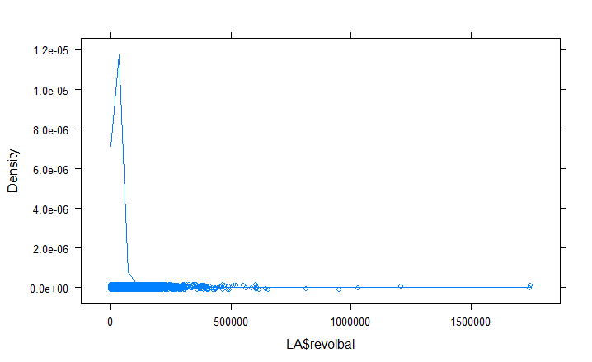
Removing the outliers over $500k removes 18 cases/outliers
LA <-filter(LA, revolbal <= 500000)

Revolving Utilisation Rate
==============

Doing a density plot for Utilisation rate shows some Outliers here too.
Placing the filter on at 1.1 removes 39 outliers.
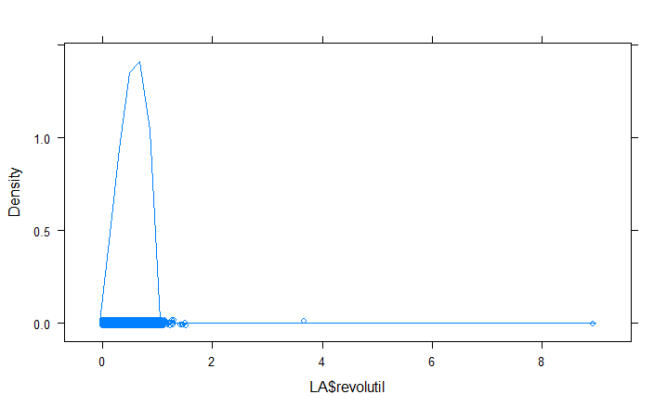

LA <-filter(LA, revolutil <=1.1)

 | No. Removed | Leaving
Loans 2007-2015 |  | 887,391
Remove Loans issued in 2015
 | 421,097 | 466,294 (2007-2014)
Only Completed Loans: Remove status of ‘Current’,‘Withdrawn’,‘Removed’, ‘Not Yet Issued’ etc
 | 213,059 | 253,235
Remove outliers
Annual income | 34 | 235,201
Revolving Balance | 18 | 234,183
Revolving Utilisation Rate | 39 | 253,144

Map
Conveniently, map_data(“state”) will get all of the latitude and longitude data for each state so that we can draw a map of the U.S.
install.packages("maps")
states <- map_data("state")
state.names <- unlist(sapply(LA$addrstate, function(x) if(length(state.name[grep(x, state.abb)]) == 0) "District of Columbia" else state.name[grep(x, state.abb)]) )
LA$addrstate <- tolower(state.names)

colnames(LA)[31] <- "region"
state.counts <- data.frame(table(LA$region))
colnames(state.counts) <- c("region", "Num.Loans")
result<-merge(state.counts, states, by=c("region"))
result <- result[order(result$order),]
p <- ggplot(result, aes(x=long, y=lat, group=group, fill=Num.Loans)) + geom_polygon() + scale_fill_gradient(low = "yellow", high = "blue") + coord_equal(ratio=1.75)
print(p)

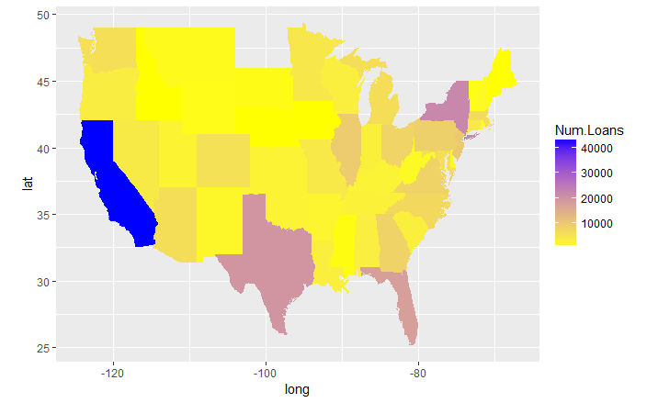

Since the number of loans can range anywhere from 3 in Maine to 6,452 in California,we can also plot the log of the total number of loans in order to more easily compare each state’s loan activity visually. We will assign its Num.Loans variable a value of 1 since we will be taking the log for our next visualization and log(1) = 0.
We can see that most of Lending Club’s borrowers are from CA, which makes sense given that Lending Club is headquartered in San Francisco. They also have vast reach across Texas, Florida, New York, a good portion of the east coast, and states bordering California. They have the least number of borrowers in Maine and parts of the West to Midwest.
p <- ggplot(result, aes(x=long, y=lat, group=group, fill=Num.Loans)) + geom_polygon() + scale_fill_gradient(low = "yellow", high = "blue", trans="log") + coord_equal(ratio=1.75)
> print (p)

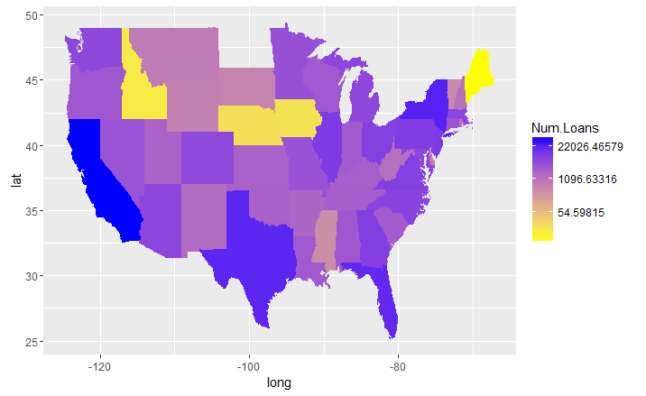

annual.income <-aggregate(LA$annualinc, by=list(LA$region), function(x) median(x, na.rm=TRUE))
colnames(annual.income) <- c("region", "annual.income")
result <- merge(annual.income, states, by="region")
p <- ggplot(result, aes(x=long, y=lat)) + geom_polygon(data=result, aes(x=long, y=lat, group = group, fill=annual.income)) + scale_fill_gradient(low="yellow", high="purple") + coord_equal(ratio=1.75)
print(p)

We will look at the median annual incomes by state.
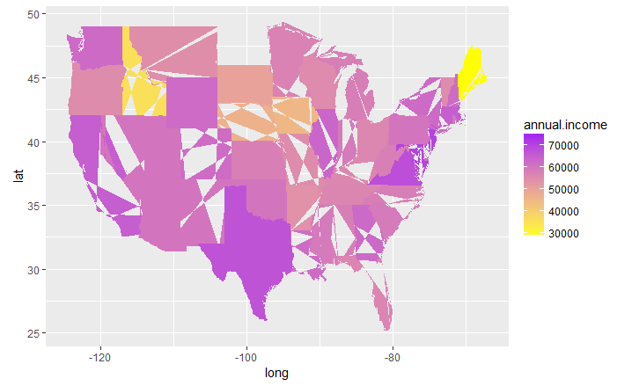

Let’s add the total number of loans in each state using geom_text() to the center of each state to give this information a little more context.

state.info<-data.frame(region = tolower(state.name), long=state.center$x, lat=state.center$y)
state.info <- subset(state.info, !region %in% c("alaska", "hawaii"))
totals <- data.frame(table(LA$region))
colnames(totals) <- c("region", "total")
state.info <- merge(state.info, totals)
p + geom_text(data=state.info, aes(label=total, cex=0.5))

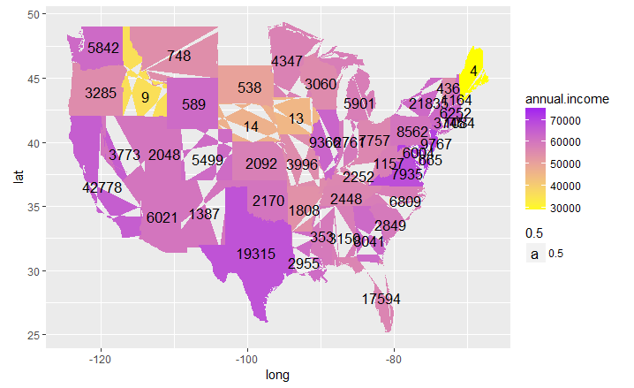

Rate by Credit Grade
Interest Rates get higher with worse Credit Ratings
- By Subgrade
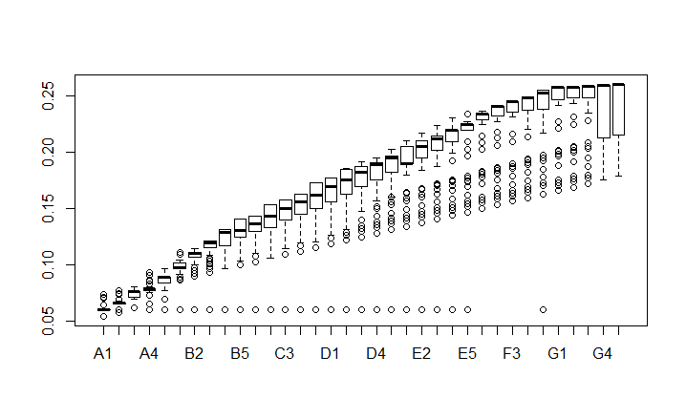

LA$rate <- LA$intrate
LA$gr <- LA$subgrade
> boxplot(rate ~ gr, data=LA)

- By Grade
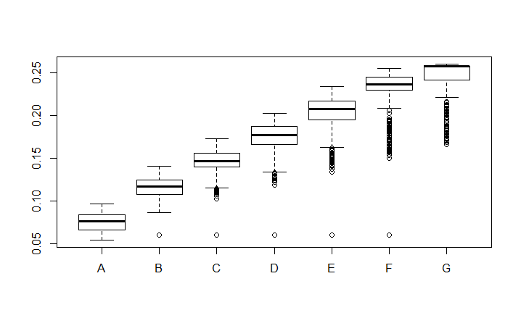
LA$rate <- LA$intrate
LA$grd <- LA$grade
boxplot(rate ~ grd, data=LA)

Revolving Line Utilisation Per Grade
Revolving Line Utilization seems to be higher for worse Credit Ratings
- By SubGrade
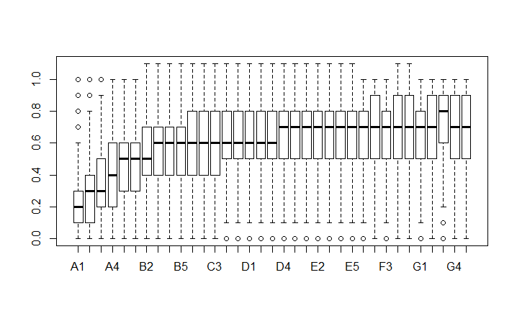
LA$gr <- LA$subgrade
LA$rul <- round(LA$revolutil,1)
boxplot(rul ~ gr, data=LA)

- By Grade
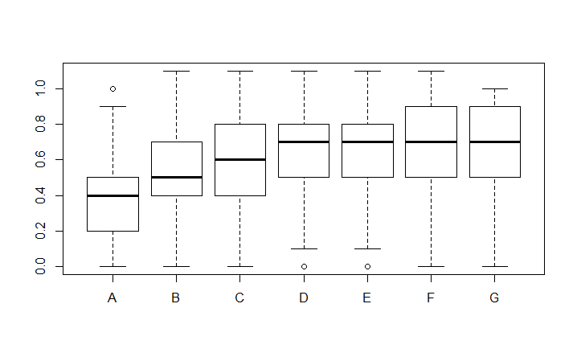
LA$grd <- LA$grade
LA$rul <- round(LA$revolutil,1)
boxplot(rul ~ grd, data=LA)

Rate Per Revolving Line Utilisation
Interest Rates get higher with higher existing Revolving Line Utilization
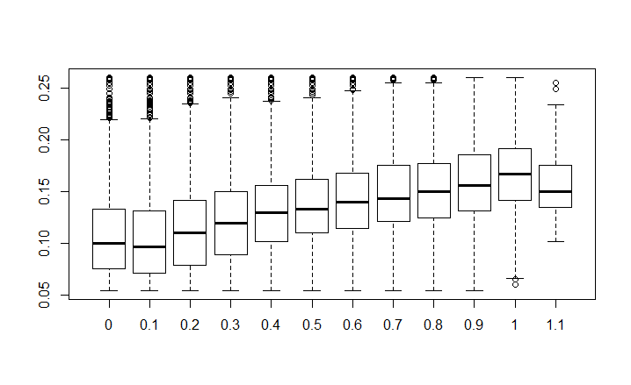
LA$rate <- LA$intrate
LA$rul <- round(LA$revolutil,1)
boxplot(rate ~ rul, data=LA)

Loan Purpose

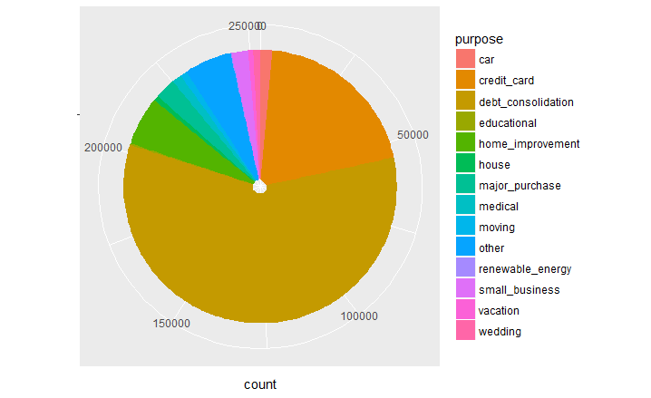

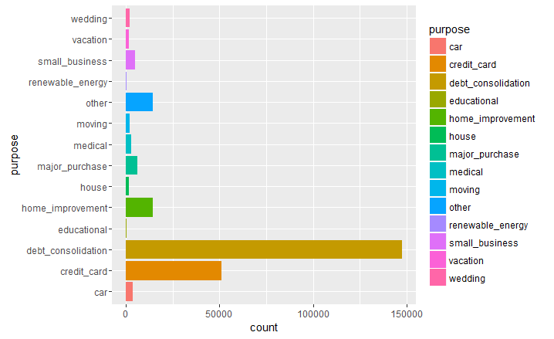
ggplot(LA, aes(purpose, fill = purpose) ) + geom_bar() + coord_flip()

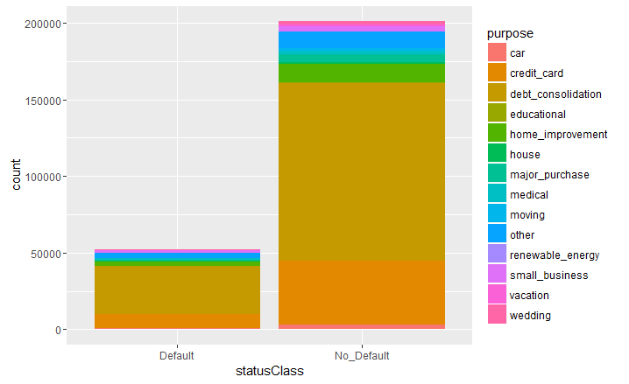
ggplot(LA, aes(statusClass, fill = purpose) ) + geom_bar(position = "stack")

In the plot above, the height of the bars represents the total number of males and females. This is fine if you want to compare counts, but if you want to compare proportions of each gender that took each class, you would have to make the bars equal heights

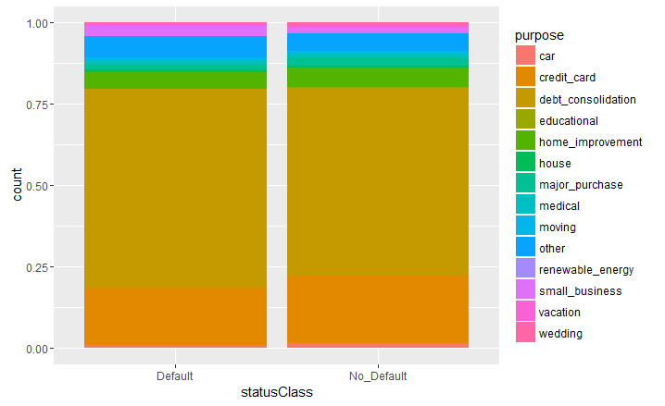
ggplot(LA, aes(statusClass, fill=purpose) ) + geom_bar(position="fill")

Useful functions:
To facilitate our discovery and manipulation of the data we created some useful functions that will be used repetitively:

# used to generate summaries grouping by ... and showing how much loan amount and how many loans were issued by groups

sumAmnts = function(x, ...) {
x %>% group_by(., ...) %>%
summarise(., total_issued = prettyNum(round(sum(loan_amnt/1)),big.mark = ","),
n = prettyNum(round(n()),big.mark = ","))
}

# remove the "pretty numbers" to enable the use of the results in formula
sumAmnt = function(x, ...) {
x %>% group_by(., ...) %>%
summarise(., total_issued = round(sum(loanamnt /1e6),1),
n = round(n()))
}

# used to generate summaries grouping by ... and showing usefull statics about each group
sumStats = function(x, ...) {
x %>% group_by(., ...) %>%
summarise(., median = prettyNum(round(median(loan_amnt/1)),big.mark = ","),
average = prettyNum(round(mean(loanamnt /1)),big.mark = ","),
stdev = prettyNum(round(sd(loanamnt /1)),big.mark = ","))
}

# used to generate summaries grouping by ... and showing usefull statics about each group
# remove the "pretty numbers" to enable the use of the results in formula
sumStat = function(x, ...) {
x %>% group_by(., ...) %>%
summarise(., median = round(median(loanamnt /1)),
average = round(mean(loanamnt /1)),
stdev = round(sd(loanamnt/1)))
}

# used to generate summaries grouping by ... and showing how much loan amount is in each status
sumPerSatus = function(x, ...){
x %>% group_by(...) %>%
summarize(., Defaulted = round(sum(statusClass == "Default") / n() * 100, 2),
avg_grade = sub_grade_vec[mean(LC_score)])}

Data Binning
Creating buckets to enable classifications:

Bucket Loan Purpose
As seen in the previous plots there are a number of Loan purposes that can be neatly grouped for ease of use.

# reduce the number of categories of purpose
LA = mutate(LA, purpose_new = ifelse(purpose == "credit_card" |
purpose == "debt_consolidation", "debt",
ifelse(purpose == "car" |
purpose == "major_purchase" |
purpose == "vacation" |
purpose == "wedding" |
purpose == "medical" |
purpose == "other", "purchase",
ifelse(purpose == "house" |
purpose == "home_improvement" |
purpose == "moving" |
purpose == "renewable_energy", "purchase", purpose))))

Bucket Home ownership

# reduce the number of categories of homeownership
LA = mutate(LA, home = ifelse(homeownership == "ANY" | homeownership == "NONE", "OTHER", homeownership))

# give LA grade numeric values
sub_grade_vec = unique(LA$subgrade) %>% .[order(., decreasing = T)]
LA = mutate(LA, LA_score = match(subgrade, sub_grade_vec))

Give LC grade numeric values
sub_grade_vec = unique(LC$sub_grade) %>% .[order(., decreasing = T)]
LC = mutate(LC, LC_score = match(sub_grade, sub_grade_vec))

Bucket Loan Description Length

LA = mutate(LA, desclength = ifelse(desclength >= 2000, "2000+",
ifelse(desclength >= 1000, "1000-2000",
ifelse(desclength >= 500, "500-1000",
ifelse(desclength >= 200, "200-500",
ifelse(desclength >= 100, "100-200",
ifelse(desclength >= 50, "50-100",
ifelse(desclength >= 1, "1-50", 0))))))))

Bucket Employee Title (job title) Description Length
LA = mutate(LA, emptitlelength = ifelse(emptitlelength >= 40, "40+",
ifelse(emptitlelength >= 20, "20-40",
ifelse(emptitlelength >= 15, "15-20", ifelse(emptitlelength >= 10, "10-15",
ifelse(emptitlelength >= 5,"5-10",
ifelse(emptitlelength >= 1, "1-5", 0)))))))
Bucket Loan Title Description Length
LA = mutate(LA, titlelength = ifelse(titlelength >= 50, "50+",
ifelse(titlelength >= 30, "30-50",
ifelse(titlelength >= 18, "18-30", ifelse(titlelength >= 15, "15-18",
ifelse(titlelength >= 10,"10-15",
ifelse(titlelength >= 5, "5-10",
ifelse(titlelength >= 1, "1-5", 0))))))))

Bucket Number of delinquencies Last 2 years

Reminder – had cr4eated this field at first round of exploration :
numofdelinq = ifelse(is.na(mthssincelastdelinq), 0,
ifelse(mthssincelastdelinq > 24 & delinq2yrs == 0,1,delinq2yrs)),

LA = mutate(LA, numofdelinq = ifelse(numofdelinq >= 10, "10+",
ifelse(numofdelinq >= 6,"6-10",
ifelse(numofdelinq >= 3, "3-5", ifelse(numofdelinq >= 1, "1-2", 0)))))

Bucket inq Last 6 Months

# inq_last_6mths buckets:
LA = mutate(LA, inq_bucket = ifelse(inqlast6mths >= 7, "7+",
ifelse(inqlast6mths >= 5, "5-6",
ifelse(inqlast6mths >= 3, "3-4",
ifelse(inqlast6mths >= 1, "1-2", 0)))))
Bucket Public Records

# public record buckets:
LA = mutate(LA, rec_bucket = #ifelse(pubrec >= 10, "10+",
#ifelse(pubrec >= 7, "7-9",
#ifelse(pubrec >= 4, "4-6",
ifelse(pubrec >= 1, "1+", 0))#)))

Annual income quantile buckets:
groupvec = quantile(LA$annualinc, seq(0,1,0.1))
labels = c(0, prettyNum(groupvec[2:10], big.mark = ","), "+inf")
labels = paste(labels[1:10], labels[2:11], sep = "-")
LA = mutate(LA, annual_inc_bucket = cut(LA$annualinc, breaks = groupvec, labels = factor(labels), include.lowest=TRUE))

DTI quantile buckets
groupvec = quantile(LA$dti, seq(0,1,0.1))
labels = c(0, prettyNum(groupvec[2:10], big.mark = ","), "+inf")
labels = paste(labels[1:10], labels[2:11], sep = "-")
LA = mutate(LA, dti_bucket = cut(LA$dti, breaks = groupvec, labels = factor(labels), include.lowest=TRUE))

Revolving Utilisation Rate quantile buckets
LA = mutate(LA, revol = as.numeric(gsub("%","",revolutil)))
groupvec = quantile(LA$revol, seq(0,1,0.1))
labels = c(0, prettyNum(groupvec[2:10], big.mark = ","), "+inf")
labels = paste(labels[1:10], labels[2:11], sep = "-")
LA = mutate(LA, revol_bucket = cut(LA$revol, breaks = groupvec, labels = factor(labels), include.lowest=TRUE))

Revolving Balance Rate quantile buckets
groupvec = quantile(LA$revolbal, seq(0,1,0.1))
labels = c(0, prettyNum(groupvec[2:10], big.mark = ","), "+inf")
labels = paste(labels[1:10], labels[2:11], sep = "-")
LA = mutate(LA, revol_bal_bucket = cut(LA$revolbal, breaks = groupvec, labels = factor(labels), include.lowest=TRUE))

Open accounts quantile buckets
groupvec = quantile(LA$openacc, seq(0,1,0.1))
labels = c(0, prettyNum(groupvec[2:10], big.mark = ","), "+inf")
labels = paste(labels[1:10], labels[2:11], sep = "-")
LA = mutate(LA, open_acc_bucket = cut(LA$openacc, breaks = groupvec, labels = factor(labels), include.lowest=TRUE))

Loan Amount quantile buckets
groupvec = quantile(LA$loanamnt, seq(0,1,0.1))
labels = c(0, prettyNum(groupvec[2:10], big.mark = ","), "+inf")
labels = paste(labels[1:10], labels[2:11], sep = "-")
LA = mutate(LA, loanamnt_bucket = cut(LA$loanamnt, breaks = groupvec, labels = factor(labels), include.lowest=TRUE))

Looking at different statistics and disributions of LC grades:

# Looking at grade statistics:
# Report showing the amounts and number of loans in each category, here LC grades
sumAmnts(LA, grade)

grade total_issued n
(fctr) (chr) (chr)
1 A 508,651,275 41,430
2 B 953,980,425 76,668
3 C 867,993,175 64,890
4 D 581,936,300 41,048
5 E 333,867,050 19,274
6 F 144,402,250 7,749
7 G 42,532,750 2,085

# Report showing some statistics for each category, here LA grades
sumStats(LA, grade)

grade median average stdev
(fctr) (chr) (chr) (chr)
1 A 10,475 12,277 7,106
2 B 10,962 12,443 7,011
3 C 11,700 13,376 8,084
4 D 12,000 14,177 8,658
5 E 16,000 17,322 9,549
6 F 18,550 18,635 9,319
7 G 20,000 20,399 8,758

Second look at the data

Exploration of the relationship between Loan Amount and Grade
I wanted to explore whether there would be an obvious linear relationship between the Grade assigned and the amount borrowed, as it seems to make sense that a borrower would be more likely to be able to repay a small amount than a large amount, so the risk of the loan defaulting would be higher as the loan amount increased, so the Grade would be worse. At first, it seems obvious that the Grade and Loan amount are correlated:

gradeVSloanamnt = group_by(LA, grade) %>% summarise(., avg_amount = mean(loanamnt))
qplot(grade, avg_amount, data = gradeVSloanamnt, geom = "boxplot", color = grade) +
theme_economist() +
scale_fill_economist() +
xlab(toupper("LA Grades ranging from A to G")) +
ylab("Loan Amount") +
ggtitle("AVERAGE LOAN AMOUNT VS. GRADES")
plot 1

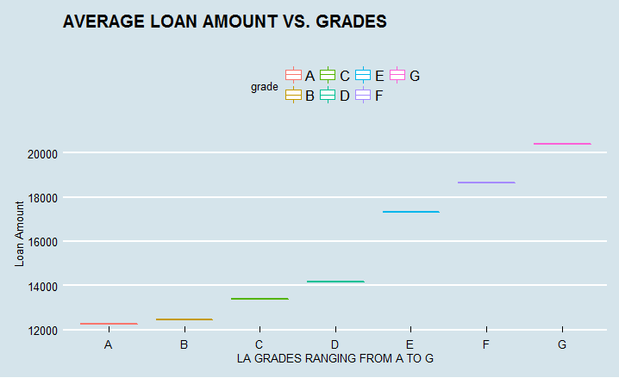

But this graph already seems to imply otherwise. Indeed 20 of the 35 possible LendingClub sub grades have average Loan amounts within $2k of each other.

subgradeVSloanamnt = group_by(LA, subgrade) %>% summarise(., avg_loanamnt = mean(loanamnt))
qplot(x = subgrade, y = avg_loanamnt, data = subgradeVSloanamnt, group = 1, geom = "point", size = I(2), col = I("steelblue")) +
theme_economist() +
scale_fill_economist() +
xlab(toupper("LA SUB Grades ranging from A1 to G5")) +
ylab("LOAN AMOUNT") +
ggtitle(toupper("Average Loan Amount vs. LA SUB Grades"))

Plot 2
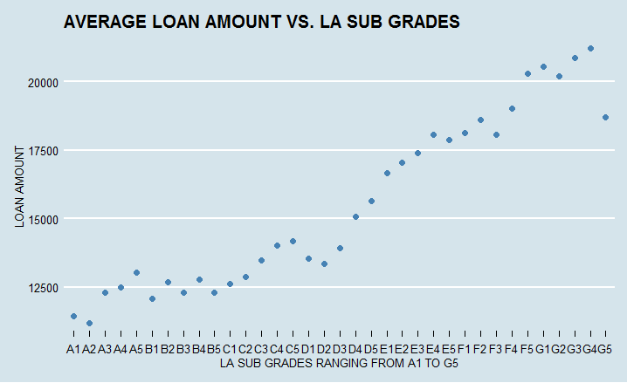

Running the full distribution subgrades actually make it a little more clear that there is a positive correlations here, although arguably grades A & B have close ditributions and medians

qplot(grade, loanamnt, data = LA, geom = "boxplot", color = grade) +
theme_economist() +
scale_fill_economist() +
xlab(toupper("LC Grades ranging from A to G")) +
ylab("LOAN AMOUNTS") +
ggtitle(toupper("Box plot of Loan Amt distribution for each Grade"))

Plot 3 below shows the distribution of Loan amounts against the LC's grade:
Although there is a trend, we can see on this plot that some borrowers with very high loan amounts got really good LC Grades

Plot 3
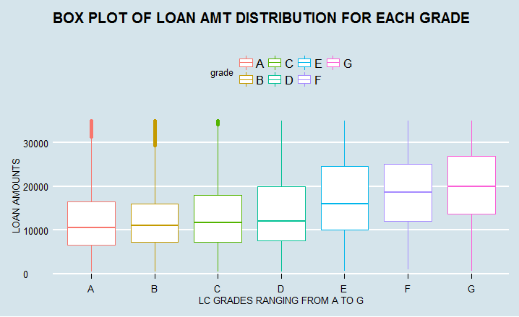

Plot 4
qplot(grade, loanamnt, data = LA, geom = "violin", color = grade) +
theme_economist() +
scale_fill_economist() +
xlab(toupper("LC Grades ranging from A to G")) +
ylab("LOAN AMOUNT") +
ggtitle(toupper("Box plot Loan Amt distribution for each LC Grade"))

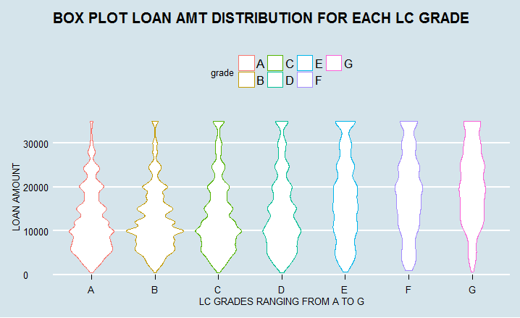

In this plot we can see the shape of the distribution . Values in the wide part of the violin are more probable than in the narrower parts. So a $10k loan with a grade of B is more probable than a 10k loan with a grade of G. A $30K loan with a grade of G is more probably than a $30k loan with a grade of A.

Exploration of the relationship between Interest Rate and Grade
I wanted to explore whether there would be an obvious linear relationship between the Grade assigned and the amount interest rate. It seems obvious that the Grade and Interest Rate are very correlated:

gradeVSintrate = group_by(LA, grade) %>% summarise(., avg_intrate = mean(intrate))
qplot(grade, avg_intrate, data = gradeVSintrate, geom = "boxplot", color = grade) +
theme_economist() +
scale_fill_economist() +
xlab(toupper("Grades ranging from A to G")) +
ylab("Interest Rate") +
ggtitle("AVG INTEREST RATE VS. GRADE")
plot 1
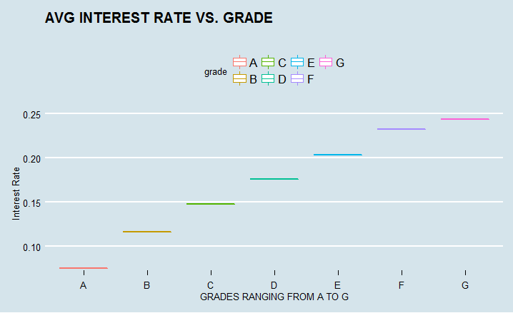

subgradeVSloanamnt = group_by(LA, subgrade) %>% summarise(., avg_loanamnt = mean(loanamnt))
qplot(x = subgrade, y = avg_loanamnt, data = subgradeVSloanamnt, group = 1, geom = "point", size = I(2), col = I("steelblue")) +
theme_economist() +
scale_fill_economist() +
xlab(toupper("LA SUB Grades ranging from A1 to G5")) +
ylab("LOAN AMOUNT") +
ggtitle(toupper("Average Loan Amount vs. LA SUB Grades"))

Plot 2

subgradeVSintrate = group_by(LA, subgrade) %>% summarise(., avg_intrate = mean(intrate))
qplot(x = subgrade, y = avg_intrate, data = subgradeVSintrate, group = 1, geom = "point", size = I(2), col = I("steelblue")) +
theme_economist() +
scale_fill_economist() +
xlab(toupper("SUB Grades ranging from A1 to G5")) +
ylab("INTEREST RATE") +
ggtitle(toupper("Avg Interest Rate vs. LA SUB Grades"))

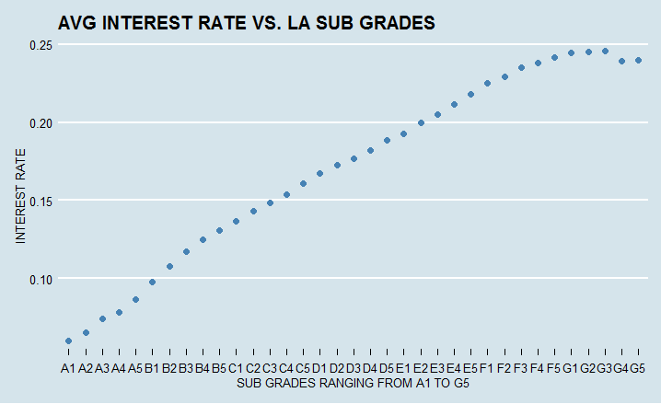

Running the full distribution subgrades actually make it a little more clear that there is a highly positive correlation here.

Plot 3

qplot(grade, intrate, data = LA, geom = "boxplot", color = grade) +
+ theme_economist() +
+ scale_fill_economist() +
+ xlab(toupper("LC Grades ranging from A to G")) +
+ ylab("INTEREST RATE") +
+ ggtitle(toupper("Box plot of Interest Rate distr for each Grade"))

Plot 3 below shows the distribution of Interest Rates against the LC's grade:
although there is a trend, we can see on this plot that some borrowers with the worst of the credit grades (G, F & E) got
relatively low interest rates.

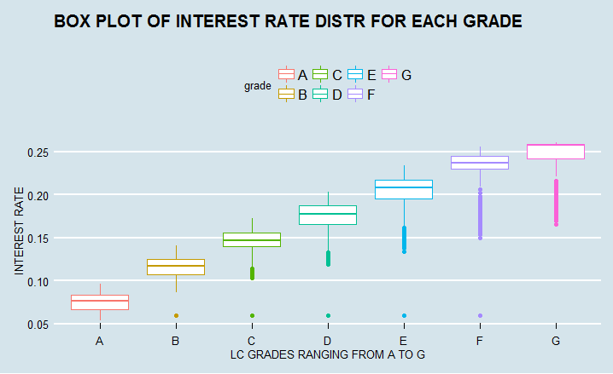

Plot 4
qplot(grade, loanamnt, data = LA, geom = "violin", color = grade) +
theme_economist() +
scale_fill_economist() +
xlab(toupper("LC Grades ranging from A to G")) +
ylab("LOAN AMOUNT") +
ggtitle(toupper("Box plot Loan Amt distribution for each LC Grade"))

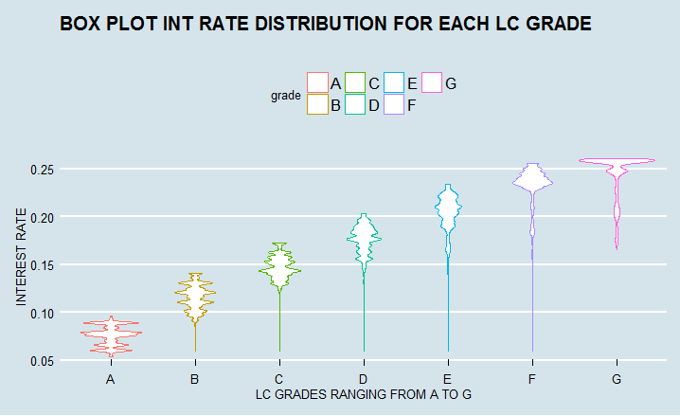

In this plot we can see the shape of the distribution . Values in the wide part of the violin are more probable than in the narrower parts, so its more likely that a Grade G will get an interest rate of >0.5 than <0.25

Third Look at the data Exploration and discovery of the predictive strength of each features:
In this section we will take each features given at the time of the origination of the debt and attempt to extract their relation to default rates.

Home ownership:
Home ownership: Does home ownership have any relashionship with defaults and grades?
Report showing the amounts and number of loans in each category, here the home ownership status of the borrower.
sumAmnts(LA, home)

homeownership total_issued n
(fctr) (chr) (chr)
1 ANY 5,000 1
2 MORTGAGE 1,884,880,775 124,487
3 NONE 578,775 44
4 OTHER 1,894,025 177
5 OWN 273,016,100 21,324
6 RENT 1,272,988,550 107,111

Report showing some statistics for each category, here the home ownership status of the borrower.
sumPerSatus(LA, home)

homeownership Defaulted avg_grade
(fctr) (dbl) (chr)
1 ANY 0.00 B4
2 MORTGAGE 18.62 C2
3 NONE 18.18 C3
4 OTHER 21.47 C4
5 OWN 21.73 C3
6 RENT 22.64 C3

Here is a pie chart of our 4 home ownership categories:

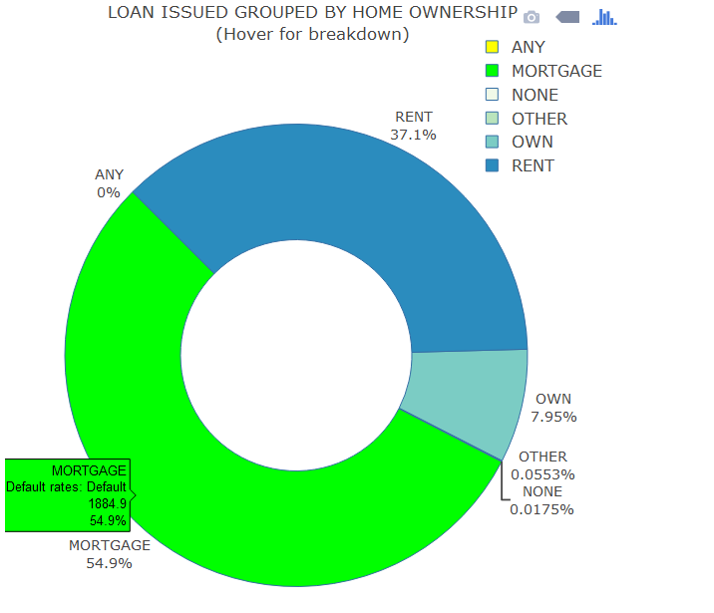

Purpose:
Purpose: We want to see if there is any relations between LC Grades, Defaults and purpose. There is a strong correlation between default rates and if the purpose is small business. These loans tend to be a lot riskier. The Lending Club Grade seems to partially capture that risk:
Report showing the amounts and number of loans in each category, here the purpose of the borrower

sumAmnts(LA, purpose)

purpose total_issued n
(fctr) (chr) (chr)
1 car 27,997,800 3,604
2 credit_card 707,609,125 51,018
3 debt_consolidation 2,133,793,825 147,767
4 educational 2,790,300 419
5 home_improvement 196,501,925 14,602
6 house 23,848,275 1,592
7 major_purchase 61,086,050 6,242
8 medical 24,684,725 2,817
9 moving 14,498,150 1,970
10 other 132,398,700 14,282
11 renewable_energy 2,650,400 266
12 small_business 75,256,825 4,974
13 vacation 9,018,425 1,529
14 wedding 21,228,700 2,062

Report showing some statistics for each category, here the purpose of the borrower.

sumPerSatus(LA, purpose)

purpose Defaulted avg_grade
(fctr) (dbl) (chr)
1 car 13.82 B5
2 credit_card 18.03 C1
3 debt_consolidation 21.51 C3
4 educational 21.00 C2
5 home_improvement 18.22 C2
6 house 20.16 C4
7 major_purchase 15.41 C1
8 medical 22.51 C4
9 moving 23.71 C5
10 other 23.18 C5
11 renewable_energy 21.05 C3
12 small_business 31.00 C5
13 vacation 19.88 C3
14 wedding 13.92 C3

sumAmnt(LA, purpose) %>% merge(sumPerSatus(LA, purpose)) %>%
plot_ly(type = "pie",
labels = LA$purpose,
values = total_issued,
hole = 0.5,
marker = list(colors = c("#FF007F","#7F00FF","#00FF7F", "#FF00FF", "#ffcc99","#66ffb2","#ffcce5","#FFFF00","#00FF00","#f0f9e8", "#bae4bc", "#7bccc4", "#2b8cbe","#FF0000"),
line = list(width = 1, color = "rgb(52, 110, 165)")),
sort = F,
direction = "clockwise",
rotation = -15,
textinfo = "label+percent",
textfont = list(size = 14),
text = paste("Default rates: ", LA$statusClass),
textposition = "outside") %>%
layout(title = 'LOAN ISSUED GROUPED BY PURPOSE<br>(Hover for breakdown)',
height = 718, width = 617, autosize = T,
legend = list(font = list(size = 14), x = 0.95, y = 1, traceorder = "normal"))

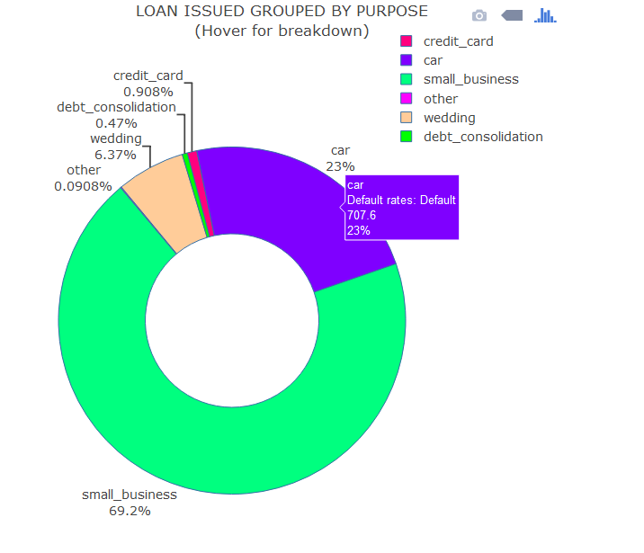

Revolving balance and employment length:
Revolving Balance, along with Employment length are actually the features with the least obvious link to default rates:
sumAmnts(LA, revol_bal_bucket)

revol_bal_bucket total_issued n
(fctr) (chr) (chr)
1 0-2,991 225,822,250 25,319
2 2,991-5,039.6 234,847,050 25,310
3 5,039.6-6,901 257,162,125 25,316
4 6,901-8,857 282,224,575 25,315
5 8,857-11,060 309,917,075 25,324
6 11,060-13,673 338,714,300 25,305
7 13,673-17,036 375,561,150 25,317
8 17,036-21,857 419,460,100 25,311
9 21,857-30,395.7 470,543,150 25,312
10 30,395.7-+inf 519,111,450 25,315

Report showing some statistics for each category, here the revolving balance of the borrower

sumPerSatus(LA, revol_bal_bucket)

revol_bal_bucket Defaulted avg_grade
(fctr) (dbl) (chr)
1 0-2,991 18.19 C2
2 2,991-5,039.6 19.71 C2
3 5,039.6-6,901 20.47 C2
4 6,901-8,857 20.98 C2
5 8,857-11,060 20.96 C3
6 11,060-13,673 21.49 C3
7 13,673-17,036 21.75 C3
8 17,036-21,857 21.54 C3
9 21,857-30,395.7 21.06 C3
10 30,395.7-+inf 19.69 C3

Report showing the amounts and number of loans in each category, here the employement length of the borrower.
sumAmnts(LA, emplength)[c(12,1,2,4,5,6,7,8,9,10,11,3),]

emplength total_issued n
(fctr) (chr) (chr)
1 n/a 106,722,775 9,860
2 < 1 year 259,135,300 21,036
3 1 year 211,226,675 16,942
4 2 years 299,761,400 23,606
5 3 years 265,376,525 20,560
6 4 years 209,181,750 16,211
7 5 years 240,368,600 18,229
8 6 years 204,718,275 15,177
9 7 years 197,252,375 14,245
10 8 years 165,142,600 11,796
11 9 years 135,743,400 9,577
12 10+ years 1,138,733,550 75,905

Report showing some statistics for each category, here the employement length of the borrower.

sumPerSatus(LA, emplength)[c(12,1,2,4,5,6,7,8,9,10,11,3),]

emplength Defaulted avg_grade
(fctr) (dbl) (chr)
1 n/a 29.16 C3
2 < 1 year 20.95 C2
3 1 year 19.89 C2
4 2 years 19.66 C2
5 3 years 20.00 C2
6 4 years 19.30 C2
7 5 years 19.81 C2
8 6 years 20.53 C2
9 7 years 20.77 C3
10 8 years 21.43 C3
11 9 years 21.41 C3
12 10+ years 20.17 C3

Number of opened accounts:
Total number of Open accounts is not the most impactful feature.
Report showing the amounts and number of loans in each category, here the number of opened accounts of the borrower.

sumAmnts(LA, open_acc_bucket)

open_acc_bucket total_issued n
(fctr) (chr) (chr)
1 0-6 455,708,450 42,873
2 6-7 259,311,400 21,163
3 7-8 298,129,525 23,366
4 8-9 322,232,475 24,384
5 9-10 311,858,550 22,982
6 10-11 299,570,025 21,219
7 11-13 501,727,400 34,281
8 13-14 196,085,900 13,041
9 14-17 402,531,625 25,984
10 17-+inf 386,207,875 23,851

sumPerSatus(LA, open_acc_bucket)

open_acc_bucket Defaulted avg_grade
(fctr) (dbl) (chr)
1 0-6 18.98 C3
2 6-7 19.98 C2
3 7-8 19.77 C2
4 8-9 20.52 C2
5 9-10 21.02 C2
6 10-11 21.15 C3
7 11-13 20.89 C3
8 13-14 21.21 C3
9 14-17 21.39 C3
10 17-+inf 22.31 C3

Months since most recent 90-day or worse rating:
Months since most recent 90-day or worse rating is not the most impactful feature. But it is interesting to note that if its over 75 months since their last 90 DPD then the borrower is more likely to default than if its in the last 45 days
Report showing the amounts and number of loans in each category, here the number of Months since most recent 90-day or worse rating.

sumAmnts(LA, mthssincelastmajorderog)

mthssincelastmajorderog total_issued n
(fctr) (chr) (chr)
1 >75 35,704,750 2,862
2 0-45 346,782,425 25,372
3 46-75 228,866,475 17,793
4 Never 2,822,009,575 207,117

Report showing some statistics for each category, here Months since most recent 90-day or worse rating
sumPerSatus(LA, mthssincelastmajorderog)

mthssincelastmajorderog Defaulted avg_grade
(fctr) (dbl) (chr)
1 >75 23.31 C4
2 0-45 22.76 C4
3 46-75 22.57 C4
4 Never 20.11 C2

The number of months since the last public record.:
Basically if a borrower has 0 public records its an indicator that he has greater chances to pay off his debts and conversely, if the number of public records is greater than 0, the borrower has a greater chance of default.
Report showing the amounts and number of loans in each category, here the number of months since the last public record.

sumAmnts(LA, mthssincelastrecord)

mthssincelastrecord total_issued n
(fctr) (chr) (chr)
1 0-77 165,808,000 14,819
2 78-129 191,301,275 16,157
3 Never 3,076,253,950 222,168

sumPerSatus(LA, mthssincelastrecord)
)

mthssincelastrecord Defaulted avg_grade
(fctr) (dbl) (chr)
1 0-77 20.83 C5
2 78-129 23.33 C4
3 Never 20.37 C2

DTI (Debt To Income ratio):
The DTI ratio:The DTI ratio: the lower the better, a DTI of 5 means your debts payment excluding mortgage, are only 5% of your gross income. DTI vs LendingClub Grade, has the expected trend, shows a strong dependency.

Report showing the amounts and number of loans in each category, here the DTI of the borrower.
sumAmnts(LA, dti_bucket)

dti_bucket total_issued n
(fctr) (chr) (chr)
1 0-0.0645 299,039,725 25,372
2 0.0645-0.0951 330,663,750 25,311
3 0.0951-0.1194 339,457,850 25,188
4 0.1194-0.141 349,773,925 25,463
5 0.141-0.1622 351,011,225 25,243
6 0.1622-0.1839 354,825,075 25,347
7 0.1839-0.207 355,210,150 25,305
8 0.207-0.2335 350,135,075 25,287
9 0.2335-0.2704 354,434,875 25,352
10 0.2704-+inf 348,811,575 25,276

Report showing some statistics for each category, here the DTI of the borrower.

sumPerSatus(LA, dti_bucket)

dti_bucket Defaulted avg_grade
(fctr) (dbl) (chr)
1 0-0.0645 14.30 C1
2 0.0645-0.0951 15.57 C1
3 0.0951-0.1194 16.97 C2
4 0.1194-0.141 17.91 C2
5 0.141-0.1622 18.75 C2
6 0.1622-0.1839 20.58 C3
7 0.1839-0.207 21.81 C3
8 0.207-0.2335 23.63 C3
9 0.2335-0.2704 25.89 C3
10 0.2704-+inf 30.46 C4

qplot(grade, dti, data = LA, geom = "boxplot", color = grade) +
theme_economist() +
scale_fill_economist() +
xlab(toupper("Grades ranging from A to G")) +
ylab(toupper("DTI (Debt to income ratio, in percent")) +
ggtitle(toupper("DTI distribution vs. LA Grades"))

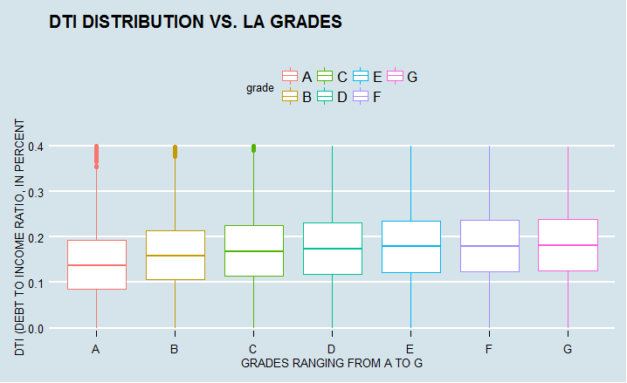

Public records:
Public Records:This feature I would have expected to be definitely correlated to default rates, but its value is very low. It is zero in most cases.
Basically if a borrower has 0 public records its an indicator that he has greater chances to pay off his debts and conversely, if the number of public records is greater than 0, the borrower has a greater chance of default.

Report showing the amounts and number of loans in each category, here the number of public records of the borrower

sumAmnts(LA, rec_bucket)

rec_bucket total_issued n
(chr) (chr) (chr)
1 0 3,088,224,975 223,438
2 1+ 345,138,250 29,706

Report showing some statistics for each category, here the number of public records of the borrower

sumPerSatus(LA, rec_bucket)

rec_bucket Defaulted avg_grade
(chr) (dbl) (chr)
1 0 20.39 C2
2 1+ 22.04 C4

Revolving utilization:
As expected, higher revolving utilization mean higher risk of default. The top 10% has default rates that are over twice as low as the bottom 10%.
Report showing the amounts and number of loans in each category, here the revolving utilization of the borrower.

sumAmnts(LA, revol_bucket)

revol_bucket total_issued n
(fctr) (chr) (chr)
1 0-0.204 295,035,725 25,370
2 0.204-0.328 309,696,750 25,408
3 0.328-0.419 328,891,825 25,403
4 0.419-0.497 343,328,950 25,386
5 0.497-0.568 345,744,825 25,012
6 0.568-0.638 358,666,125 25,482
7 0.638-0.708 362,408,475 25,148
8 0.708-0.784 368,155,275 25,358
9 0.784-0.871 369,077,275 25,343
10 0.871-+inf 352,358,000 25,234

Report showing some statistics for each category, here the revolving utilization of the borrower

sumPerSatus(LA, revol_bucket

revol_bucket Defaulted avg_grade
(fctr) (dbl) (chr)
1 0-0.204 12.81 B4
2 0.204-0.328 16.46 B5
3 0.328-0.419 18.32 C1
4 0.419-0.497 20.00 C2
5 0.497-0.568 20.87 C2
6 0.568-0.638 21.81 C3
7 0.638-0.708 22.71 C3
8 0.708-0.784 23.18 C4
9 0.784-0.871 23.96 C5
10 0.871-+inf 25.79 D1

Annual income:
This is a very strong feature. People in the top 20% quantile have half as many defaulted loans compared to the bottom 20%. It is worth noticing though, that even the top 20% still get a 15% chance off defaulting on their loan which is still very high. So annual income is not a silver bullet either.
Report showing the amounts and number of loans in each category, here the annual income of the borrower.
sumAmnts(LA, annual_inc_bucket)
annual_inc_bucket total_issued n
(fctr) (chr) (chr)
1 0-33,000 170,092,875 25,704
2 33,000-40,500 230,755,900 24,980
3 40,500-48,000 282,889,550 26,385
4 48,000-55,000 341,981,100 28,709
5 55,000-61,922.5 269,659,600 20,794
6 61,922.5-70,000 385,056,550 27,413
7 70,000-80,000 387,964,650 25,287
8 80,000-95,000 424,374,900 25,274
9 95,000-120,000 471,449,650 25,996
10 120,000-+inf 469,138,450 22,602

Report showing some statistics for each category, here the age of the annual income of the borrower
sumPerSatus(LA, annual_inc_bucket)

annual_inc_bucket Defaulted avg_grade
(fctr) (dbl) (chr)
1 0-33,000 26.20 C3
2 33,000-40,500 24.81 C3
3 40,500-48,000 23.23 C3
4 48,000-55,000 22.10 C3
5 55,000-61,922.5 21.82 C3
6 61,922.5-70,000 20.21 C3
7 70,000-80,000 18.89 C3
8 80,000-95,000 17.04 C2
9 95,000-120,000 16.05 C2
10 120,000-+inf 14.94 C2

Inquiries in the last 6months:
This feature is supposed to represent how desperate the borrower is for credit. We can see that the correlation between this feature and Default rates is very strong. This is the feature that has a very high impact on default rates.
Report showing the amounts and number of loans in each category, here the number of inquiries of the borrower.

sumAmnts(LA, inq_bucket)
inq_bucket total_issued n
(chr) (chr) (chr)
1 0 1,656,476,500 121,753
2 1-2 1,452,070,925 107,450
3 3-4 283,387,050 20,812
4 5-6 36,858,900 2,675
5 7+ 4,569,850 454

Report showing some statistics for each category, here the age of the number of inquieries of the borrower.

sumPerSatus(LA, inq_bucket)
inq_bucket Defaulted avg_grade
(chr) (dbl) (chr)
1 0 18.57 C1
2 1-2 21.77 C4
3 3-4 25.04 C5
4 5-6 27.48 D2
5 7+ 35.68 E1

Length of Loan Description as written by the borrower:
Loan description provided by the borrower, and I have calculated the length of each description and bucketed it. There is correlation between this feature and Default rates. If the borrower writes no description, or writes a description of over 2000 characters then they have equal probability of default. However those borrowers that write upto 1000 characters, reduce their probability of default with each character they write. Once they go over 1000 characters however, the probability of default starts to rise again. This factor interests me as it is a behavioural factor in reality.
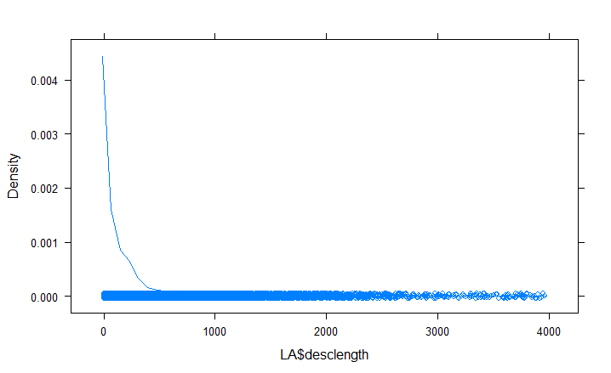
Report showing the amounts and number of loans in each category, here the length of Loan description written by the borrower.

sumAmnts(LA, desclength)
desclength total_issued n
(chr) (chr) (chr)
1 0 2,168,524,375 157,529
2 1-50 231,037,100 17,747
3 100-200 305,800,325 22,866
4 1000-2000 24,965,475 1,946
5 200-500 367,137,050 27,421
6 2000+ 5,937,825 416
7 50-100 246,940,750 18,681
8 500-1000 83,020,325 6,538

Report showing some statistics for each category, here here the length of Loan description written by the borrower.

sumPerSatus(LA, desclength)
desclength Defaulted avg_grade
(chr) (dbl) (chr)
1 0 22.16 C3
2 1-50 20.53 C2
3 100-200 17.92 C1
4 1000-2000 16.55 C3
5 200-500 16.49 C1
6 2000+ 22.36 C5
7 50-100 19.00 C2
8 500-1000 14.99 C2

Length of Employee title Description as written by the borrower:
Thisis the job title supplied by the Borrower when applying for the Loan. I have calculated the length of each job title description provided by the borrower, and bucketed it. There is correlation between this feature and Default rates but it is interestingly not reflected in Lending Clubs grade.
If the borrower’s job title contains no characters then they have a 27.5% probability of defaulting, each charcter they write reduces the probability of default, almost slashing it by 50% when they use >40 characters to describe their job title. This reflects the strong correlation between this field and default. This factor is very interesting as it is a behavioural factor in actuality.
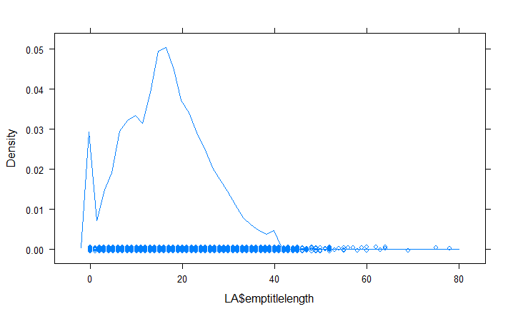
Report showing the amounts and number of loans in each category, here the length of job title description written by the borrower.

sumAmnts(LA, emptitlelength)
emptitlelength total_issued n
(chr) (chr) (chr)
1 0 169,970,400 14,255
2 1-5 140,440,025 10,022
3 10-15 619,234,175 45,951
4 15-20 823,955,325 60,300
5 20-40 1,154,606,325 83,970
6 40+ 25,218,050 1,805
7 5-10 499,938,925 36,84

Report showing some statistics for each category, here e the length of the job title description written by the borrower.

sumPerSatus(LA, emptitlelength)
emptitlelength Defaulted avg_grade
(chr) (dbl) (chr)
1 0 27.48 C2
2 1-5 20.61 C3
3 10-15 21.10 C3
4 15-20 20.06 C3
5 20-40 18.49 C2
6 40+ 16.62 C2
7 5-10 23.11 C3

Length of Loan Description as written by the borrower:
This is the Loan title supplied by the Borrower when applying for the Loan. I have calculated the length of each loan title provided by the borrower, and bucketed it. There is a pattern here, certainly borrowers who write a loan title of over 50 characters have only an 8% probability of default, in contrast with those borrowers who write one or 2 word titles (5-10 characters) who have a 22% probability of default .
However those who leave the Loan title blank, and those who write 30-50 characters have more or less the same probability of default, so perhaps we cannot read too much into this factors impact at the moment. Again this factor can be classified as a behavioural factor as it is filled by the borrower.
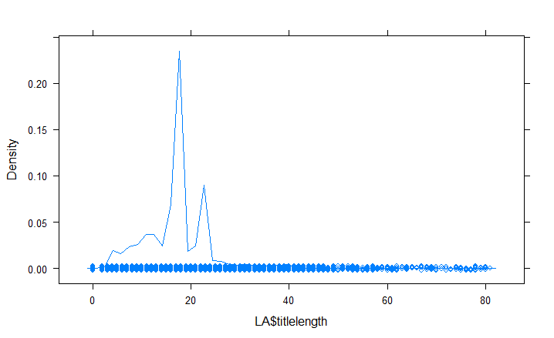
Report showing the amounts and number of loans in each category, here the length of Loan title written by the borrower.

sumAmnts(LA, titlelength)
titlelength total_issued n
(chr) (chr) (chr)
1 0 127,650 12
2 1-5 59,451,050 5,037
3 10-15 502,028,700 39,852
4 15-18 299,067,975 22,941
5 18-30 2,069,910,300 143,587
6 30-50 130,058,150 9,878
7 5-10 370,385,525 31,622
8 50+ 2,333,875 215

Report showing some statistics for each category, here the length of the job title description written by the borrower.

sumPerSatus(LA, titlelength)
titlelength Defaulted avg_grade
(chr) (dbl) (chr)
1 0 16.67 D1
2 1-5 18.46 C2
3 10-15 18.94 C2
4 15-18 19.35 C2
5 18-30 21.30 C3
6 30-50 16.27 C2
7 5-10 22.08 C3
8 50+ 8.84 C2

Verification Status
The verification status indicates if income was verified by LC, not verified, or if the income source was verified. Displays obvious correlation with default rate.

Report showing the amounts and number of loans in each category, here the verification status of the borrower.

sumAmnts(LA, verificationstatus)
verificationstatus total_issued n
(fctr) (chr) (chr)
1 Not Verified 845,002,225 87,467
2 Source Verified 1,008,202,750 71,511
3 Verified 1,580,158,250 94,166

Report showing some statistics for each category, here the verification status of the borrower.

sumPerSatus(LA, verificationstatus)

verificationstatus Defaulted avg_grade
(fctr) (dbl) (chr)
1 Not Verified 16.23 C1
2 Source Verified 22.41 C3
3 Verified 23.25 C4

Loan Amount
The listed amount of the loan applied for by the borrower. If at some point in time, the credit department reduces the loan amount, then it will be reflected in this value.
We saw in our earlier data analysis that the Loan amount was strongly correlated to Interest Rate, so it is no surprise here to see there a definite pattern, with default rates increasing in line with increasing Amounts borrowed. Strangely the Lending Club credit grade does not reflect this.

Report showing the amounts and number of loans in each category, here the amount of the borrower’s loan.

sumAmnts(LA, loanamnt_bucket)

loanamnt_bucket total_issued n
(fctr) (chr) (chr)
1 0-4,800 84,839,275 26,782
2 4,800-6,300 132,184,225 23,858
3 6,300-8,050 187,702,175 25,378
4 8,050-10,000 331,895,350 34,743
5 10,000-12,000 302,976,700 26,304
6 12,000-14,400 216,765,300 16,145
7 14,400-16,500 372,934,750 24,263
8 16,500-20,000 554,429,525 29,474
9 20,000-25,000 545,078,500 23,569
10 25,000-+inf 704,557,425 22,628

Report showing some statistics for each category, here the amount of the borrower’s loan.
sumPerSatus(LA, loanamnt_bucket)

loanamnt_bucket Defaulted avg_grade
(fctr) (dbl) (chr)
1 0-4,800 17.35 C2
2 4,800-6,300 17.42 C1
3 6,300-8,050 17.65 C1
4 8,050-10,000 19.26 C1
5 10,000-12,000 19.86 C2
6 12,000-14,400 20.60 C3
7 14,400-16,500 21.58 C2
8 16,500-20,000 22.77 C3
9 20,000-25,000 23.74 C4
10 25,000-+inf 26.72 D2

Final Cleanup – Remove unapplicable columns

Set character variables to factors

LA$desclength=as.factor(LA$desclength)
LA$emptitlelength=as.factor(LA$emptitlelength)
LA$titlelength=as.factor(LA$titlelength)
LA$region=as.factor(LA$region)

In our earlier data exploration we saw that interest rate was highly correlatyed with Grade and subgrade, so we will removed interest rate from our dataset.
As subgrade is a more detailed form of grade we shall use this and remove grade.

colRemove <- c("annualinc", "dti", "inqlast6mths", "openacc","pubrec", "revolbal", "revolutil","applicationtype", "rate","gr","grd","rul","revol","df$homeownership","initialliststatus","outprncp","outprncpinv","numofdelinq", "loanamnt", "termmonths","installment","grade","issued","intrate","LC_score"
)

LA <- LA[,!names(LA) %in% colRemove]

'data.frame': 253144 obs. of 20 variables:
$ subgrade : Factor w/ 35 levels "A1","A2","A3",..: 7 14 15 11 4 21 27 10 13 10 ...
$ emplength : Factor w/ 13 levels "","< 1 year",..: 4 2 4 4 6 12 7 2 8 4 ...
$ homeownership : Factor w/ 7 levels "","ANY","MORTGAGE",..: 7 7 7 7 7 7 6 7 6 6 ...
$ verificationstatus : Factor w/ 4 levels "","Not Verified",..: 4 3 2 3 3 3 3 4 2 3 ...
$ purpose : Factor w/ 15 levels "","car","credit_card",..: 3 2 13 11 15 2 13 11 4 4 ...
$ region : Factor w/ 50 levels "alabama","alaska",..: 3 11 14 5 3 5 5 43 3 5 ...
$ mthssincelastrecord : Factor w/ 3 levels "0-77","78-129",..: 3 3 3 3 3 3 3 3 3 3 ...
$ mthssincelastmajorderog: Factor w/ 4 levels ">75","0-45","46-75",..: 4 4 4 4 4 4 4 4 4 4 ...
$ desclength : Factor w/ 8 levels "0","1-50","100-200",..: 2 8 1 3 1 2 5 5 5 1 ...
$ emptitlelength : Factor w/ 7 levels "0","1-5","10-15",..: 1 7 1 4 5 4 1 7 5 2 ...
$ titlelength : Factor w/ 8 levels "0","1-5","10-15",..: 7 2 5 7 6 4 6 5 5 3 ...
$ statusClass : Factor w/ 2 levels "Default","No_Default": 2 1 2 2 2 2 1 1 2 2 ...
$ revol_bal_bucket : Factor w/ 10 levels "0-2,991","2,991-5,039.6",..: 6 1 1 3 4 4 3 5 2 9 ...
$ open_acc_bucket : Factor w/ 10 levels "0-6","6-7","7-8",..: 1 1 1 5 4 1 6 1 8 7 ...
$ dti_bucket : Factor w/ 10 levels "0-0.0645","0.0645-0.0951",..: 10 1 2 7 3 1 1 6 5 3 ...
$ rec_bucket : Factor w/ 2 levels "0","1+": 1 1 1 1 1 1 1 1 1 1 ...
$ revol_bucket : Factor w/ 10 levels "0-0.204","0.204-0.328",..: 9 1 10 2 2 10 2 3 2 7 ...
$ annual_inc_bucket : Factor w/ 10 levels "0-33,000","33,000-40,500",..: 1 1 1 4 2 3 2 1 7 7 ...
$ inq_bucket : Factor w/ 5 levels "0","1-2","3-4",..: 2 4 2 2 3 2 2 1 2 1 ...
$ loanamnt_bucket : Factor w/ 10 levels "0-4,800","4,800-6,300",..: 2 1 1 4 2 1 2 2 3 5 ...

Split into Training and test dataset (75% Training, 25% test)
d = sort(sample(nrow(LA), nrow(LA)*.75))
train_set<-as.data.frame(LA[d,])
test_set<-as.data.frame(LA[-d,])

